**ACTIVITY 7**

**NAME:M.shalini devi COURSE: MOBILE COMPUTING**

**REG NO : 192421351 COURSE CODE: ITA0302**

7. Develop a dashboard prototype in Figma displaying performance criteria for a cellular

system.

**Aim:** To develop a dashboard prototype in Figma displaying performance criteria for a cellular

system.

Procedure:

1. Open Figma

2. Create a new file

3. Select the Frames

4. Fill in the content that is required for presentation

5. Design Visual Elements

6. Make it Interactive

7. Add Annotations and Explanations

8. Incorporate Multimedia

9. Storyboard Animation

10. Review and edit the Prototype

11. Save and Share

**Design:**

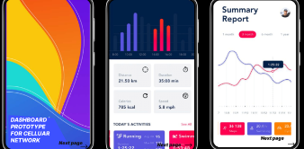

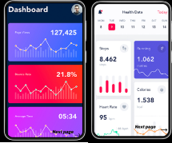

**Prototype:**

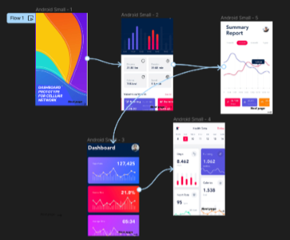

**Result:**

Hence developed a dashboard prototype in Figma displaying performance criteria for a cellular

system.